H.T No
Regulations:
A20

Sreenidhi Institute of Science and Technology
(An Autonomous Institution)
Code No:8HC11 Date:13 -August-2024 (FN)

B.Tech I-Year II- Semester External Examination, August-2024 (Supplementary)
ADVANCED CALCULUS AND COMPLEX VARIABLE (EEE AND ECE)

Time: 3 Hours Max.Marks:70

Note: a) No additional answer sheets will be provided.
b) All sub-parts of a question must be answered at one place only, otherwise it will not be valued.
c) Missing data can be assumed suitably.

Bloom's Cognitive Levels of Learning (BCLL)

Remember | L1 | Apply | L3 | Evaluate | L5
Understand | L2 | Analyze | L4 | Create | L6

Part - A Max.Marks:20
Answer all QUESTIONS

 |  | BCLL | CO(s) | Marks
1 | State law of Natural Growth ans Decay. | L1 | CO1 | [2M]
2 | Find the complementary function of 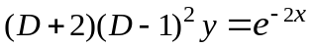 | L2 | CO2 | [2M]
3 | Evaluate | L2 | CO3 | [2M]
4 | State Stokes theorem. | L1 | CO4 | [2M]
5 | State Cauchy-Riemann equations in Polar form | L2 | CO5 | [2M]
6 | Expand 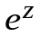as Taylor’s series in powers of | L2 | CO6 | [2M]
7 | Solve | L3 | CO2 | [2M]
8 | Evaluate | L3 | CO3 | [2M]
9 | Find the residue at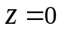of the function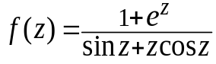 | L2 | CO6 | [2M]
10 | Solve the differential equation | L2 | CO1 | [2M]
Part – B Max.Marks:50
ANSWER ANY FIVE QUESTIONS. EACH QUESTION CARRIES 10 MARKS.

 |  |  | BCLL | CO(s) | Marks
11. | a) | Solve 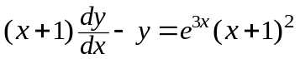 | L3 | CO1 | [5M]
 | b) | The number N of bacteria in a culture grew at a proportional to N. The value of N was initially 100 and increased to 332 in one hour. What was the value of N after 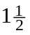hours? | L4 | CO1 | [5M]
12. | a) | Solve 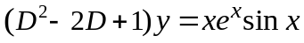 | L3 | CO2 | [5M]
 | b) | Solve the differential equations by the method of variation of parameters 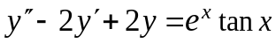 | L3 | CO2 | [5M]
13. | a) | Evaluate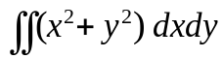 in the positive quadrant for which 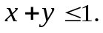 | L4 | CO3 | [5M]
 | b) | Change the order of integration and hence evaluate 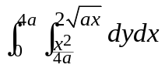 | L4 | CO3 | [5M]
14. | a) | Compute the line integral 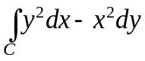about the triangle whose vertices are 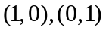and 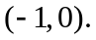 | L3 | CO4 | [5M]
 | b) | Using Green’s theorem, evaluate 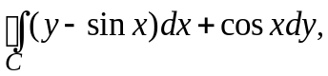where C is the plane triangle enclosed by the lines 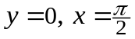 and 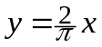 | L3 | CO4 | [5M]
15. | a) | Show that the function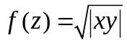is not analytic at the origin even though C-R equations are satisfied at that point. | L4 | CO5 | [5M]
 | b) | Find the image of the infinite strip 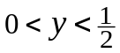 under the transformation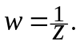 | L3 | CO5 | [5M]
16. | a) | Using Cauchy’s integral formula, evaluate 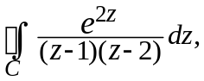where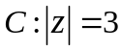 | L3 | CO6 | [5M]
 | b) | Evaluate 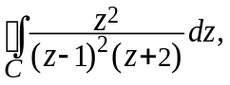 where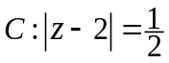using residue theorem |  | CO6 | [5M]
17. | a) | Solve 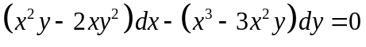 | L3 | CO1 | [4M]
 | b) | Find the general solution of 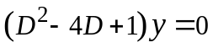 | L2 | CO2 | [3M]
 | c) | Evaluate | L2 | CO3 | [3M]
18. | a) | Evaluate where c is given by x = t , y = , z = 3t ,  1 ≤t ≤2. | L3 | CO4 | [4M]
 | b) | Determinesuch that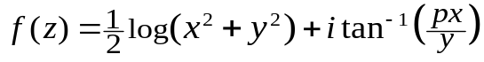be analytic function. | L2 | CO5 | [3M]
 | c) | Find the poles and residues of the following function  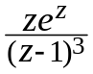 | L2 | CO6 | [3M]

-- 00 -- 00 –

